PROJECT MEMBERS

Seyfettin Kutluhan Ünsal 190444074

Ahmet Kaan Uyan 190444045

Esra Şahin 190444060

Doğa Yıldırım 190444072

HOW TO USE

To run the program you have to fallow the steps:

1. Install (tkinter ,SQL light 3 ,pillow ,opencv ,pickle) like ( pip install opencv-python) one by one.
2. Make sure Project folder includes 1 number of .png files.
3. after you run the code if you want to add product you have to be sure that camera is open.
4. If you want to find a product that you save before, the only information that you have to write is storage code then the other attribiutes automatically fills.
5. If you want a make any change to any product the sqlite file you have to be sure that the sqlite file is close.

DETAILED REVIEW

metin içeren bir resim

Açıklama otomatik olarak oluşturuldu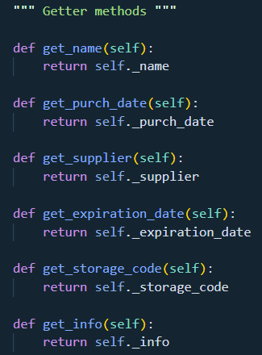The crew of the project divided 4 main topic, theese are: Camera Usage, Data Storage, Research and connections between all parts. First, we started by defining the classes after that we applied the getter and setter methods as requested in the Project at first we thought it would be difficult for us to get them like this all the time, but it made our job easier in the future.

The most difficult part was transferring the inputs we received from the user, to SQL table. We did this with SQL library and after doing that everyone was able to make new projects with SQL library. The library was very complex and it was creating unnamed rows and columns by itself. We searched the internet for solutions and finalized them. The methods that we created, wrote into the visualize class. Add product methods create an sqlite file as “products.sqlite” then start writing the attributes to rows and columns. Our index attribute was storage code we wanted to find products with the unique code like storage code.

metin içeren bir resim

Açıklama otomatik olarak oluşturuldu

According to Project we have to bulid an camera button to take products photos. It was also showed us how camera works, what is frame. As a result of research we decided to stop frame when we add new product to sqlite file and to save this frame information in hex form to the sqlite. It was also difficult to connect all parts together then we did, as the figures shows.

metin içeren bir resim

Açıklama otomatik olarak oluşturuldu

At that point we noticed that we have to process the camera part to the whole app. Also with some reaserch we got able to do that.

Last and most fun part for all members was the part of customizing the interface, when everything was finished, our application looked like:

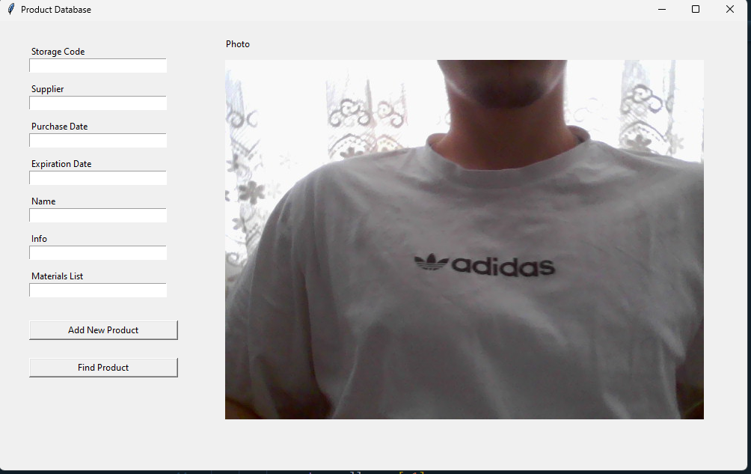

TASK DISTRIBUTION IN GROUP

All members were involved in all of the reseach and development parts.

Recording video and optimizing it to application and connections, database connections : Seyfettin Kutluhan Ünsal

Research of customization and user interface also methods in classes: Ahmet Kaan Uyan , Doğa Yıldırım, Esra Şahin